Electromagnetic Spectrum Drawing

Objective:

Create a drawing representing the electromagnetic spectrum.

Directions:

You will use a correct representation of the EM spectrum to create your own spectrum.

You must include all parts of the electromagnetic spectrum (waves, frequency, wavelength, and a “comparison” –

o All parts of the Electromagnetic Spectrum are included

* Block out the regions of all types of radiation
* Label the regions of all types of radiation

o Be sure when you include the “visual” portion of the spectrum that you break that down into the component colors

• Block out the region where the visible range is (ROYGBIV) You must use color

Regions to include:

|  |  |
| --- | --- |
| Region | Wavelength |
| Gamma Rays | 0.1 A and shorter |
| X-rays | 10 nm to 0.01 nm |
| Ultraviolet | 400 nm to 10 nm |
| Visible  Violet  Indigo  Blue  Green  Yellow  Orange  Red | 380 to 750 nm |
| 380–420 nm |
| 420–450 nm |
| 450–495 nm |
| 495–570 nm |
| 570–590 nm |
| 590–620 nm |
| 620–750 nm |
| Infra-red | 750 nm to 1 mm |
| Microwaves | 1 mm to 30 cm |
| Radio/TV | 30 cm to 10 m |
| Long-waves | 10m and longer |

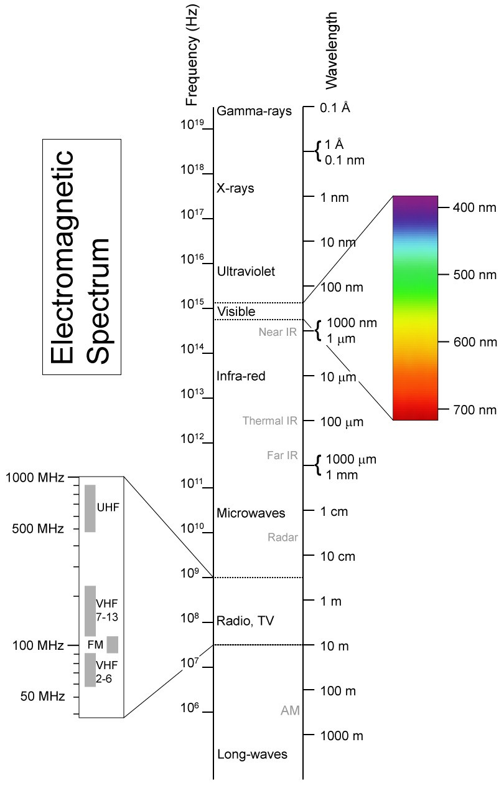

# Light and Waves Worksheet

1. The illustration below shows a series of transverse waves. Label each part in the space provided.

|  |  |  |
| --- | --- | --- |
| a |  |  |
| b |  |
| c |  |
| d |  |
| e |  |
| f |  |
| g |  |

Fill in the blanks:

1. Waves carry ________ from one place to another.
2. The highest point on a transverse wave is the while the lowest part is the
3. The is the height of the wave.
4. The distance from one crest to the next is the:
5. Below is a series of four wave images lettered A, B, C, and D.

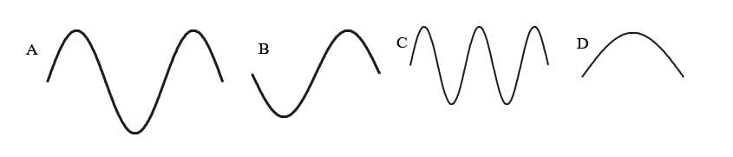

* 1. In the table, please indicate how many waves are in each image:

|  |  |
| --- | --- |
| Wave Letter | Number of Waves |
| A |  |
| B |  |
| C |  |
| D |  |

* 1. Which of the above has the shortest wavelength?
  2. Which of the above has the longest wavelength?

1. Express in words (or mathematically) the relationship between
   1. wavelength and frequency:
   2. wavelength, frequency and speed:
2. Consider a beam of electromagnetic radiation that has a frequency of 1016 Hz. This beam would be found in what region of the spectrum?

# Light & Atoms (Honors Only)

You may need to use the electromagnetic spectrum you drew or do additional research. *Answer in your own words*.

1. An atom emits a light wave with a wavelength of 449 nm. What type or color of light does this represent?

1. Is a wave with a frequency of 5x1016 Hz visible?

1. A beam of electromagnetic radiation has a wavelength of 1m. What part of the spectrum is this beam from?

1. Rank these light waves from highest to lowest energy: x-rays, radio waves, yellow light, UV, red light, violet light.

1. Rank these stellar objects from hottest to coldest using their frequencies or wavelengths.

|  |  |  |
| --- | --- | --- |
| Object | Frequency | Wavelength |
| A | 1016 Hz |  |
| B |  | 1 cm |
| C |  | 100 nm |
| D | 1013 Hz |  |
| E | 1015 Hz |  |

1. What general range of waves are more dangerous to your skin and body, high frequency or low frequency waves? {hint: high energy bursts usually cause more damage}

1. Atoms that are energized give off many separate colors, but NOT the whole rainbow of colors.
   1. Why is the number of colors limited to a specific set?
   2. Why do they give off more than one color?
2. You know the mnemonic “Roy G. Biv” for remembering the visible spectrum. Now create your own mnemonic for remember the entire electromagnetic spectrum : radio, microwave, infrared, visible, ultraviolet, x-ray, gamma ray.
3. Consider a beam of electromagnetic radiation that has a wavelength of 1 cm. This beam would be found in what region of the spectrum?
4. Light also behaves like a particle. What is this particle called?
5. Where do these particles come from?
6. How can an emission spectrum be used in astronomy?